Reflection



By

Sjoerd brauer

HBO-I definitions
Software management
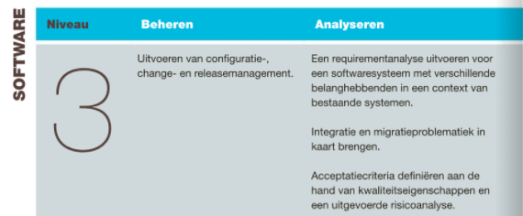
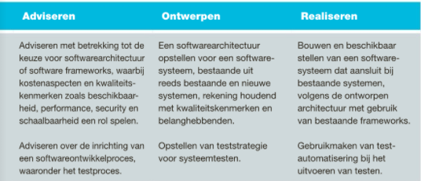

On the HBO-I website there are no definitions for research skills and profesional behaviour.
Learning goals and where to find them

LG1

See chapter 5

LG2

See chapter 1 and 3

LG3

See chapter 2 and 6

LG4

See Learning goals

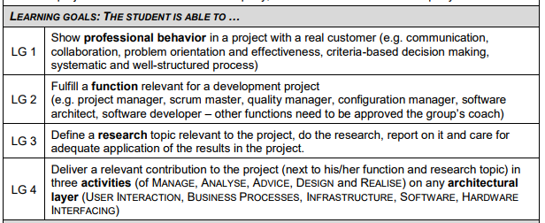
Learning goals
1 Software management
To meet level three for software management I created the CI table and informed people from time to time to update it. Other group members (who are in charge of deployment) took care of deploying the program, so in this scenario I couldn’t do a lot because the process went quite good. I can however manage the final delivery (documentation etc) in which we end the project.

Proof:
CI table: 40configuration_management\configuration_item_table
CI plan: 40configuration_management\plan
Proof of informing: 2017-10-05 Meeting.doc

2 Software advice
During the development traject I gave advice to other group members on implementing frontend and debugging.

On top of this I did a research at the start of the SOFA on which backend frameworks to use.Near the last sprint I did a second research about generating PDF’s frontend. I adviced the group actively on what to do. More about the researches can be read at chapter 6

3 Design
As group’s software architecture I designed all endpoints and corresponding communication data. I communicated this with the group and oversaw the correct implementation of the design. I also created mockups to demonstrate how frontend should look like. This helped the endpoint designing process a lot because it visualizes what one needs.

Proof of doing design can be found on trello and in:
60software_architecture\backend_interface\backend_interface.pdf
60software_architecture\backend_interface\json_objects.ods

4 Software Implementation
I never professionally worked frontend and I was/am very motivated to learn Angular. Using the Angular framework I learned to better understand SCSS, Javascript and typescript. Angular also gave me knowledge on how to test frontend using Karma. When developing I found a nice way to develop frontend code without being dependent on the backend using mockup data. Creating mockup data can be time consuming but it’s worth it because one can reuse mockup data for the tests.

5 Professional Behavior
I did a test to increase the groups motivation using food, the result though ended in the group eating the food without using the reward part. Then I switched to speeches. First I tried an allround philosophical approach. Unfortunately from my observations I noted that it didnt affect the group motivation in any way. Eventually I switched the focus of the speeches on complimenting and talking about things that went good as our strength. The impression this gave me that people enjoyed listening to these kind of things and that it was motivating. I also observed that the atmosphere become more pleasant (I’m not implying it was bad).

As can be read in section 4.6 I did two researches. That’s because I always think about what good approach would be. Secondly I think it’s important to research what existing solutions there exist and why they should be used.

Proof of food can be found in minutes: 2017-10-03 Meeting.doc
Proof of motivation speeches can be found in: 2017-10-05 Meeting.doc

6 Research skills

I did my research about backend frameworks in the beginning of the project. Furthermore I wasn’t knowledgable about Angular at all so I had to do a lot of learning and researching to properly use Angular and it’s features. I also researched about different ways of PDFgeneration frontend. What I did for both researches is distill the criteria that are needed. Wrote a short description about what the framework is doing and how it relates to what we need.

See research backend framework
30analysis\java_frameworks_backend
30analysis\pdfgeneration

